BMED 2300 Bio-Imaging and Bio-Instrumentation
Syllabus, Spring 2018

2017-2018 Catalog data: This course serves as an introduction to biomedical instrumentation and imaging with emphasis on current medical imaging modalities. Basic principles for the selection and appropriate use of instruments for solving bioengineering and medical problems such as microscopy, magnetic resonance imaging, and ultrasounds, among others, are addressed.

Textbooks:
- Fourier Transform and Its Applications (PDF with permission). Brad Osgood. SEE Program, Stanford, 2007
- Introduction to Biomedical Imaging. Andrew Webb. IEEE Press series in Biomedical Engineering, 2003.
- Bioinstrumentation. John G. Webster (Ed.). John Wiley & Sons, 2004.
- Lectures on Medical Imaging. Ge Wang, Draft version 1, 2018

References Texts: Additional materials are posted on LMS related to specific lecture topics.

Course Instructor: Hisham Mohamed, Ph.D., BME ; Ge Wang, Ph.D., BME

Course objectives: Provide students with an understanding of bioinstrumentation and bioimaging principles. Students should learn the concepts of and skills dealing with linear systems, Fourier analysis, and signal processing, understand the different methods and systems to acquire tomographic signals and reconstruct images, and have exposure to basic and clinical research and applications.

Prerequisites: Calculus II, Physics 1200, Physics II

Topics: Linear system, Fourier analysis, signal processing, image quality and performance; X-ray imaging, CT, nuclear imaging, MRI, ultrasound, optical imaging.

Computer Usage: Required for multiple homework assignments (MATLAB)

Course Content/Coverage (Tentative):
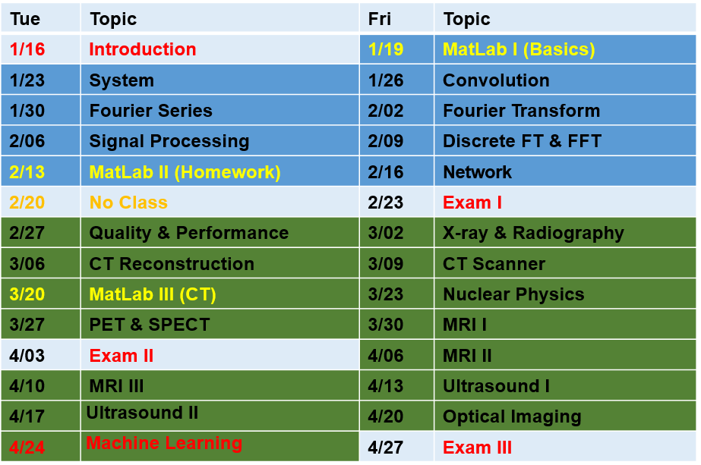

Grading:
The final grade in this course will be based on the student total score on all components of the course. The total score is broken down into the following components:
Class participation: 10% (Each day delay will receive 10% penalty)
Exam I: 20%
Exam II: 20%
Exam III: 20%
Homework: 30%

An unexcused absence from an exam will be assigned a zero grade. An excused absence requires a letter from the Dean’s office. An excused absence from a semester exam will receive an EX grade. At the end of the semester, the EX grade will be replaced with the average of the student grades on the other exams.

Grade disputes will be settled at the discretion of the instructor. The problem in question will be re-graded, making it possible for the student to receive a lower score. To dispute an exam grade, the student must explain his/her dispute in writing and staple this in front of his/her exam.

Academic Integrity

The Biomedical Engineering Department does not tolerate any act of academic dishonesty. As a student in BMED 2960, the departmental code of ethics outlined below will be followed.

“As a member of the Rensselaer Biomedical Engineering Community, I will uphold the ethical conduct befitting a Biomedical Engineer. I will not use knowledge gained from my experiences at Rensselaer for any purpose which may harm society. My actions will reflect positively on the department, university, and profession. I will respect the faculty, staff, and my peers by not misrepresenting myself through acts of deception. I will not participate in any acts of lying, cheating, or stealing in accordance with the Rensselaer Handbook of Student Rights and Responsibilities. I will conduct research with integrity. I will take pride in my work and continue to promote these principles throughout my tenure at Rensselaer and my career as a Biomedical Engineer.”

In this class, all assignments that are turned in for grade must represent the student’s own work. In cases where help was received, or teamwork was allowed, a notation on the assignment should indicate your collaboration. Submission of any assignment that is in violation of this policy will receive a failing grade for the course and reported to the Dean of Students. If you have any questions concerning this policy before submitting an assignment, please ask for clarification

Course Learning Outcomes: Students who successfully complete the course will be able to:

- Understand linear systems, Fourier analysis, and signal processing clearly;
- Perform a Fourier transform, a convolution, and simple signal processing tasks using MATLAB;
- Draw and list the critical components of tomographic scanners, and explain their working principles, strengths and limits, and key applications;
- Have a general overview of the medical imaging technologies.

ABET outcomes Supported:
(X) 3.a an ability to apply knowledge of mathematics, science, and engineering
( ) 3.b an ability to design and conduct experiments, as well as to analyze and interpret data
( ) 3.c an ability to design a system, component, or process to meet desired needs within realistic constraints such as economic, environmental, social, political, ethical, health and safety, manufacturability, and sustainability
( ) 3.d an ability to function on multi-disciplinary teams
( ) 3.e an ability to identify, formulate, and solve engineering problems
( ) 3.f an understanding of professional and ethical responsibility
( ) 3.g an ability to communicate effectively
( ) 3.h the broad education necessary to understand the impact of engineering solutions in a global, economic, environmental, and societal context
( ) 3.i a recognition of the need for, and an ability to engage in life-long learning
( ) 3.j a knowledge of contemporary issues
(X) 3.k an ability to use the techniques, skills, and modern engineering tools necessary for engineering practice.
Additional BME specific ABET requirements (Criterion 9):
( ) 9.a The program must prepare graduates to have an understanding of biology and physiology, and the capability to apply advanced mathematics (including differential equations and statistics), science, and engineering to solve the problems at the interface of engineering and biology.
(X) 9.b The curriculum must prepare graduates with the ability to make measurements on and interpret data from living systems, addressing the problems associated with the interaction between living and non-living materials and systems.

Estimated ABET Category Content:

Math & Basic Sciences ____ credit hour(s) - 50 % Credit should be in
Engineering Topics ____ credit hour(s) - 50 % ½ or whole credit amounts.

Prepared by: Ge Wang Date: 01-01-18

